NEWSLETTER - Helmond, the Netherlands

*The fourth LTT activity of our Erasmus+ project “Happy, Healthy, Wise and Wealthy” KA229 took place in our school from January 22nd to 28th January*

**On Sunday, January 22nd,** the foreign students arrived in the Netherlands. Most on Eindhoven Airport and one group at Schiphol. From there the students came with their own hosts to their temporary houses, to settle in and prepare for the week.

**On the Monday after, January 23rd**, we had an introduction day. We started at the school, with an opening ceremony. Our musical group did some acts which got followed by a tour through the school. We made little groups of Dutch students that showed around some foreign students and teachers from different countries. After this we did some speed-dating, so that everybody could get to know each other a bit. We had presentations about each countries schools and prized quizzes about the characteristic things about our countries. After this we had a tour through the city centre and the castle of Helmond.

**On Tuesday, January 24rd**, we started the pollution project. First we had a workshop gasses. It was mostly about what gasses we have in the air, where they come from and why they are a threat to our climate. After a short break we watch a documentary in which Zac Efron about problems like pollution, plastic soup, animal suffering and urbanisation. He also talk about solutions like green walls, veggie or vegan food, beach cleanups and more. All the countries also prepared a presentation about the air quality in their surroundings. We had a long break followed by an presentation at the Automotive Campus. One of the hearts of the Brainport area of Eindhoven. First we had a presentation about the ingenious solutions they are working on followed by a student who spoke about the electric race car they are building. Afterwards we all returned to our (guest)houses.

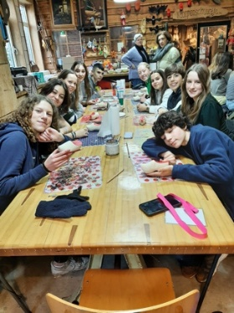**On Wednesday, January 25th,** we went to the Porcus Campus where we got a lot of information about the campus and what it had to do with air pollution. They then gave us a tour. After the tour we had a break at the Porcus Campus where we could buy some lunch to eat. After our break we went to the wooden shoe factory in Aarle-Rixtel, where they showed us how and where they made their wooden shoes. They told us all kind of fun facts and other things about wooden shoes. They then gave us all a wooden shoe which we were going to design by ourselves. Everyone painted their own wooden shoe, which was a very fun activity because it is typical Dutch.

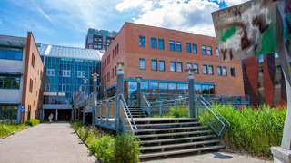**On Thursday, January 26th**, we went with the bus to Den Bosch where we went to the Green Academy university. They gave us a tour and told us all about the building, the school and what it had to do with air pollution. We had to create our own sustainable product and they gave us a lecture about air pollution in the Netherlands. After we went to the university, we had some free time and could walk and shop in Den Bosch by ourselves.

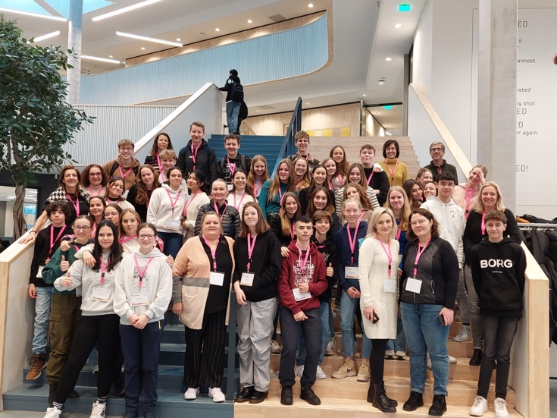

**On Friday, January 27th,** we had two workshops in the morning: a cooking workshop and a creative workshop. Everyone could choose which workshop they wanted to do. The cooking workshop made some typical Dutch lunch which we ate later that afternoon and the creative workshop had to make a creative piece of art about air pollution. In the evening we had a farewell party in which each country had to make and show their own dance.

Three out of four groups left **on** **Saturday, 28 January**. The Czech left **on Sunday, 29 January**. Except for the Portuguese group, who are going to Portugal in May, this was the final goodbye. People hugged each other and than the exchange students had to get their flight. Leaving the Netherlands seven days later and many memories richer.