Potato Gnocchi with Poppy Seeds

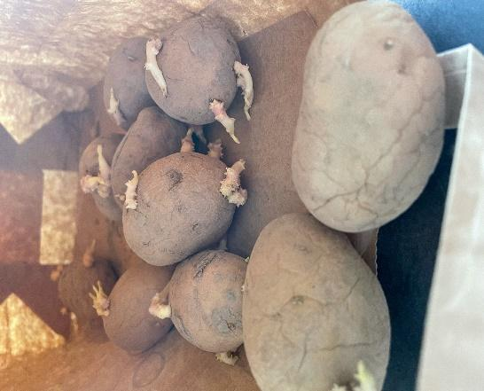
Ingredients:
800g Potatoes
2 egg yolks

120g flour
120g semolina
½ teaspoon of salt

Method:

- Boil the potatoes, peel them and grate them into tje bowl.
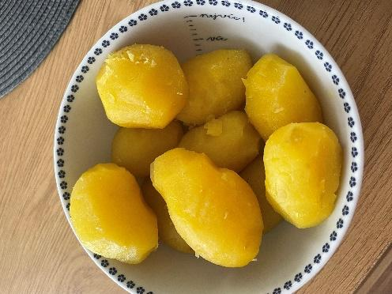
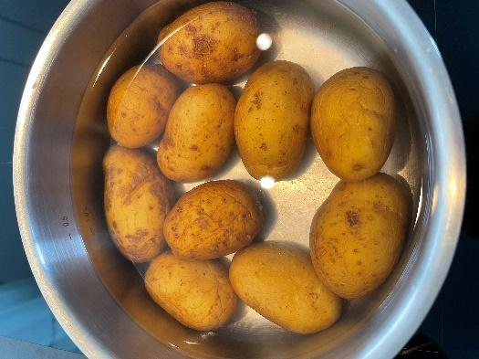
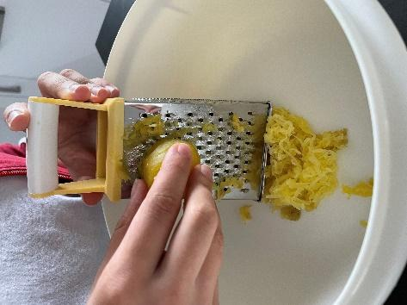

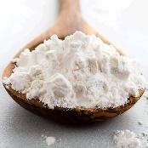
- Add the egg yolks, course flour and semolina to the potatoes (the dough should be pliable and should not stick)
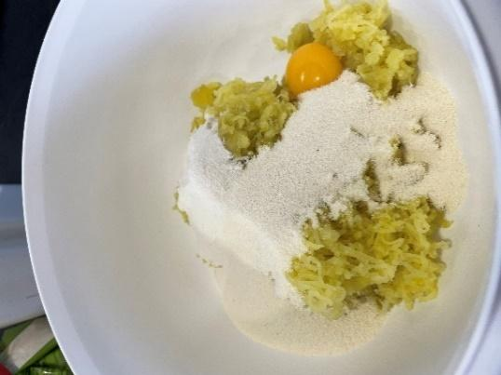
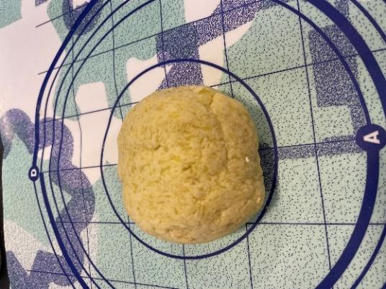
- Form 2 long rolls from the dough and cut them into small pieces.
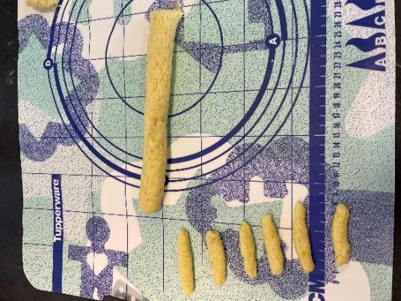

- Cook the pieces in boiling water for about 3-5 minutes.

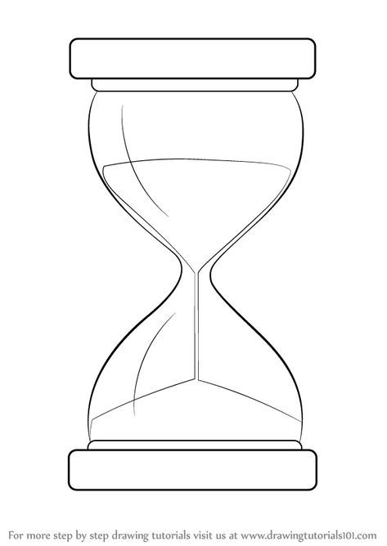

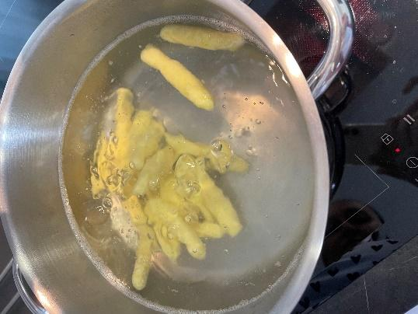

- Then serve into a plate and sprinkle with sugar, ground poppy seeds and put a small amount of butter on top.

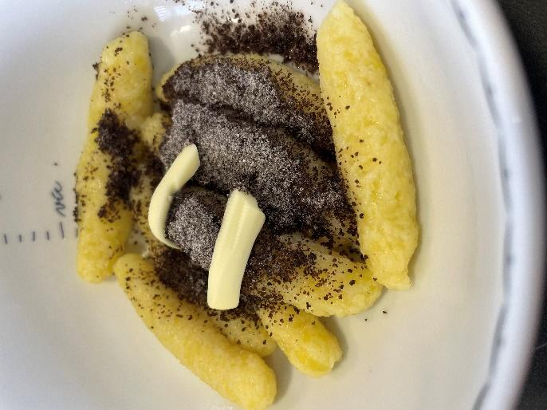

- You are done, enjoy your meal!

